
  - 
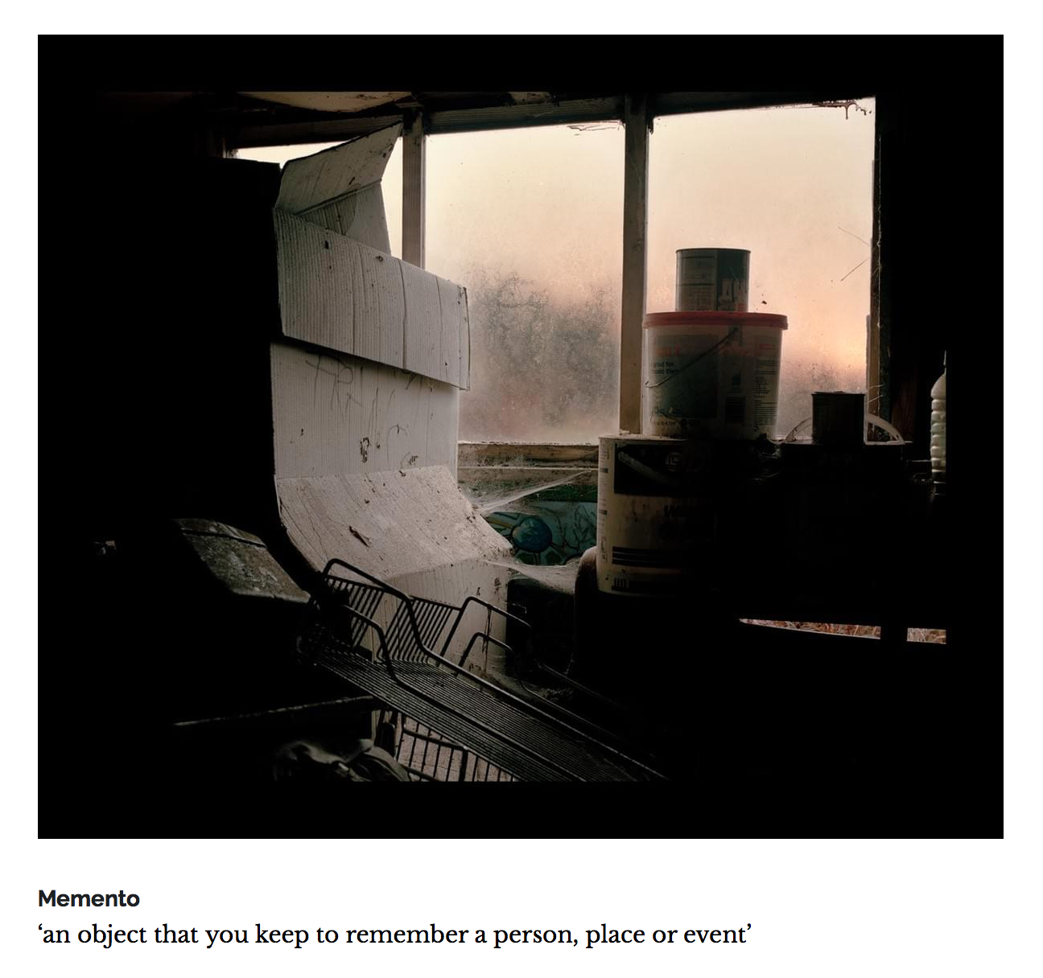

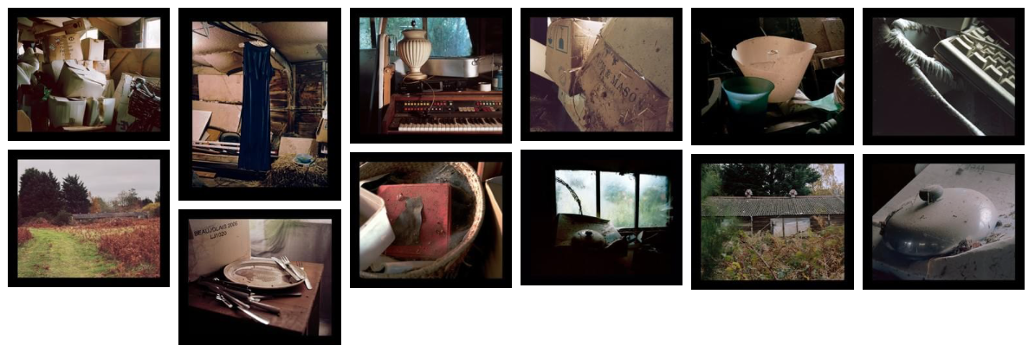
Memento

At the end of my garden is an old barn where I have been hoarding “stuff” since my mother’s death in 2005. As I stared working on this project, I realised that really the objects in my barn represented my grief. My mother’s old lamp shade, her dinner plate, the lid to one of her saucepans. These items were part of a vivid memory of the two of us eating roast chicken on a Sunday.

Many of these things are covered with years of dust and cobwebs yet in some way I believed that my mother lived on in these everyday objects and the barn had become a tomb I had created to hide away from loneliness and heart break.

As I worked, I realised that these objects were meaningless. They were just things bought from shops. In our society where consumerism is almost our new religion, I had mistakenly attached emotions to objects with no value. My mother was not inside the dark barn, she was not the genie in the lamp. In fact, she was outside in the living landscapes of beautiful Suffolk.

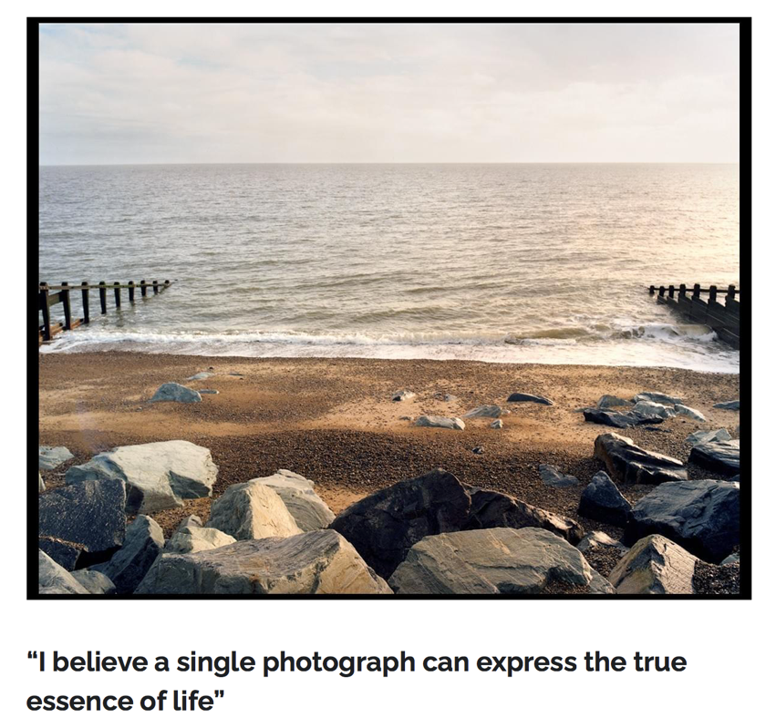
Eliza Stephens is a Suffolk based visual artist whose work focuses on documenting the interweaving of social and personal realities in the lives of her and her friends. With over 20 years of experience as a storyteller and editor in broadcast documentary television, Eliza has now moved her attention to telling stories within the photographic medium.
“I want to tell stories with 12 frames instead of using hours of footage shot over many months, I believe a single photograph can express the true essence of life.”

Eliza has worked on many ground breaking documentaries and was part of the team that won The Grierson, Broadcast, and The Royal Society of Television awards for Best Documentary in 2016. Eliza is passionate about food and education and has had two cookery books published. She also runs a lively and successful Thai restaurant and bar on the Suffolk coast.
Corona vision – “Good Morning Mr Orwell”
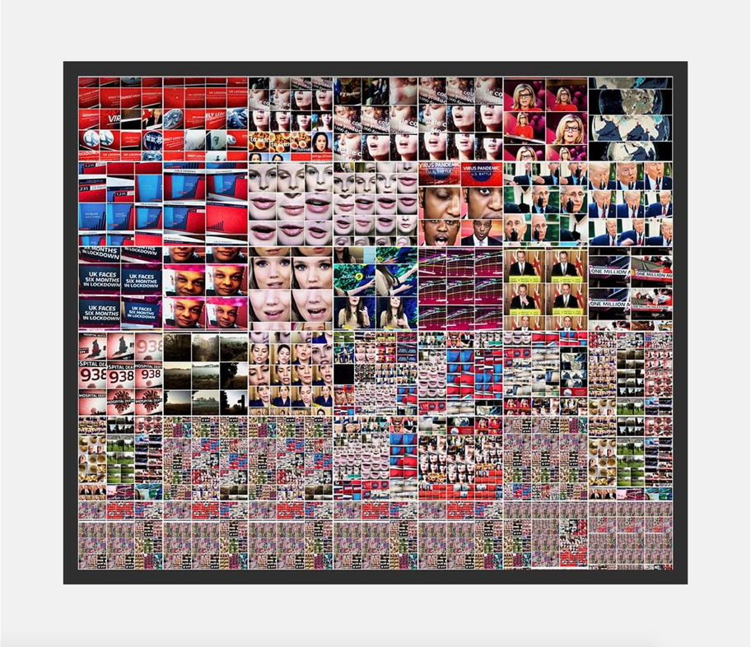
An exploration into the realms of Hyper Reality and the Main Stream Media’s representations of the pandemic during the first wave of the Coronavirus pandemic of 2020. Using the portal of televisions as the eye of God, combined with the enforced isolation of lockdown, this project narrates the first 60 days of this life-altering global event. 2020, Exhibition Project, ongoing.

Not Drowning
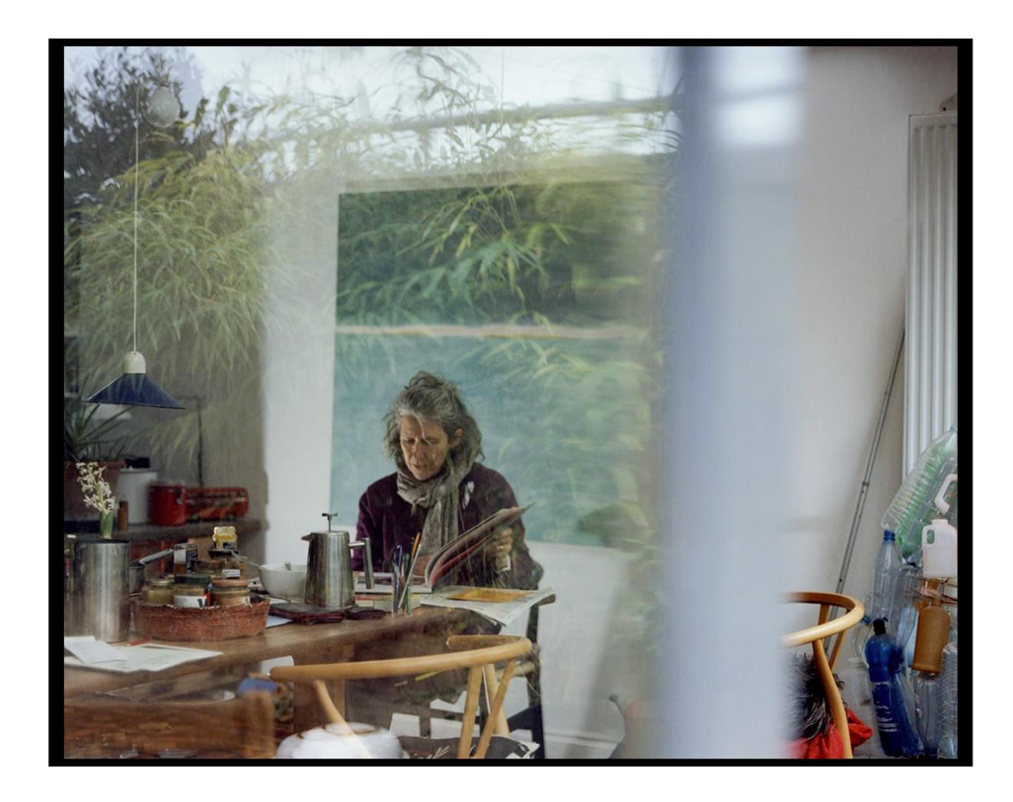
A study following the rhythms of a woman’s daily life,
Helen’s moments of joy taken while she navigates the demands of being a full-time carer for her elderly parents. Exploring this balancing act, observing her daily swims in the North Sea, her art, and other moments of self invigoration. 2019, Exhibition Project.

Dancing With Trains – Life and death in the treatment centre. A documentary project following the lives of a group of people in treatment for mental health issues. Their struggles and success for some but also the tragic death of others. 2019, Book project.

“Bish Bosh” – Turn your back on cancer. An intermit portrait of a cancer diagnosis, The initial cycle of treatment, navigation of the welfare system, getting the all-clear and then being told there was a mistake and the diagnosis was now terminal. 2018, Ongoing. Educational Exhibition Project.

Road Rash – The mistaken pride of a cyclist who is rescued from a fall on a dark night in Suffolk. 2018.

